Kinetic Energy

Kinetic Energy is a form of energy associated with the motion of an object. In equation, the kinetic energy KE of an object with mass m and speed v is:
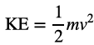
Just like work, kinetic energy is a scalar, and the SI unit is also Joules (J)

The Work-Energy Theorem

The net work done on a system equals the change of the kinetic energy of the system:
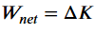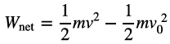

Review: Work is scientifically defined as:
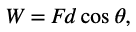
Where W is work, F is the magnitude of the force exerted, d is the magnitude of the displacement, and θ is the angle between the force vector F and the displacement vector d.

Examples for Work-Energy Theorem:

Example 1. Suppose a 30.0 kg package on the roller belt conveyor system is moving at 0.50m/s. (a) What is its kinetic energy? Suppose you push on the package with a constant force of 120 N through a distance of 0.80 m, and the opposing friction is 5.0 N (b) What is the net work done on the package? (c) What is the final speed of the package?

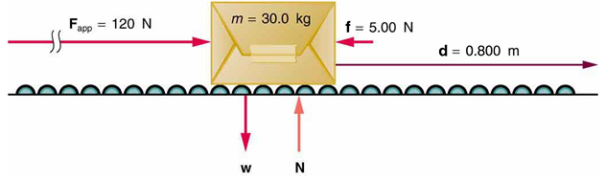

Practice Problems for Work-Energy Th:
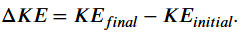

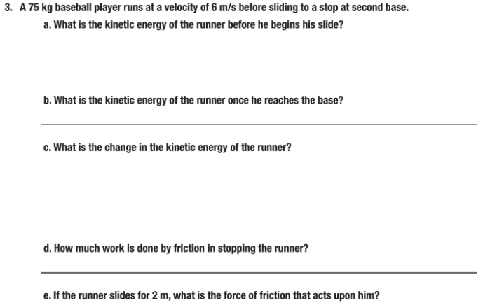

08Lab_Verifying Work-Energy Theorem(Pendulum)

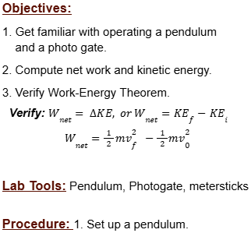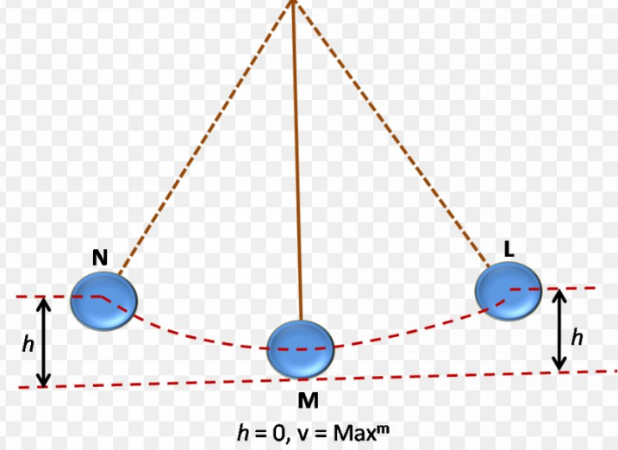

2. Play with the pendulum to learn how to carefully make the pendulum bob swing in the same plane with a small angle θ.

3. Carefully adjust the position of the photogate and pendulum so that the bob is moving through the photogate at its lowest position without hitting the photogate.

4. Practice part 3 a couple of times until you are very confident to work on it.

5. Start the pendulum bob at an initial position, measure the vertical height of the position with respect to a reference level (for example, the table surface level, or the ground level). Record it as $y_{1}$.

6. Let the pendulum bob swing to its lowest position. Measure the vertical height with respect to the same reference level. Record it as $y_{2}$.

7. Set the photogate at the bob’s lowest position, release the bob from rest at the same initial height $y_{1}$ , and let it go through the photogate. Record the speed on the photogate as $v_{f}$.

8. Repeat the above Part 5, 6, and 7 three times, but each time start the initial position at a different level, measure and record: $y_{1}$, $y_{2}$, and $v_{f}$.

9. Calculate the kinetic energy at the lowest position of the bob: ${KE}_{f 1}$, ${KE}_{f 2}$, and ${KE}_{f 3}$. Find the change of kinetic energy, Δ${KE}_{1}$, Δ${KE}_{2}$, and Δ${KE}_{3}$

10. Calculate the work done by the net force: $W_{net 1}$, $W_{net 2}$, and $W_{net 3}$.

11. By Work-Energy Theorem, compare each Δ${KE}_{}$with $W_{net }$, and see if they are equal. Calculate percent difference.

Questions: 1. Draw FBD of the pendulum bob at the initial position and the lowest position:

2. Compute Work by the definition of Work: $W=F⋅d⋅cosθ$

Work done by the tension force is _____________; Work done by the gravity is________________

Data: Fill the tables below with your measurements and your calculations:

- Your reference level of vertical zero is set at ___________________

- Mass the pendulum bob: m=_______________, convert it to kg, m=____________kg.

 | Initial Position $y_{1}$ | Final Position $y_{2}$ | Displacement $d=\left|y_{1}-y_{2}\right|$ | Net Work $W_{net }=F_{g}⋅d⋅cosθ$
1
2
3

 | Final Velocity $v_{f}^{}$ | Final Kinetic Energy ${KE}_{f}=\frac{1}{2}m{v_{f}^{2}}_{}$ | Initial Kinetic Energy ${KE}_{i}=\frac{1}{2}m{v_{0}^{2}, (v_{0}^{}=0)}_{}$ | Change in Kinetic Energy$ΔKE={KE}_{f}-{KE}_{i}$
1
2
3

Percent Error: $\frac{W_{net}-ΔKE}{ΔKE}×100\%$
1
2
3
Error Analysis: What are the possible factors for the error?

